# Desk Reader User Manual

Table of contents

Desk Reader User Manual 1

1.Operating environment 3

2.Connect Reader 4

3.Query 5

4.Read and write 6

4.1) Read and write tags 6

4.2) Write tags in batches 7

4.3) lock tag 8

4.4) Kill tag 9

4.5) Automatically calculate and add PC 9

5.Setting 11

## 1.Operating environment

This software supports systems: Windows2000, Windows XP, Windows 7, Windows 8, Windows 10, Windows 2003 and higher systems.

Applicable environment: supports USB, RS232

Note: Please turn off all firewalls on your computer when using this host computer.

## 2.Connect Reader

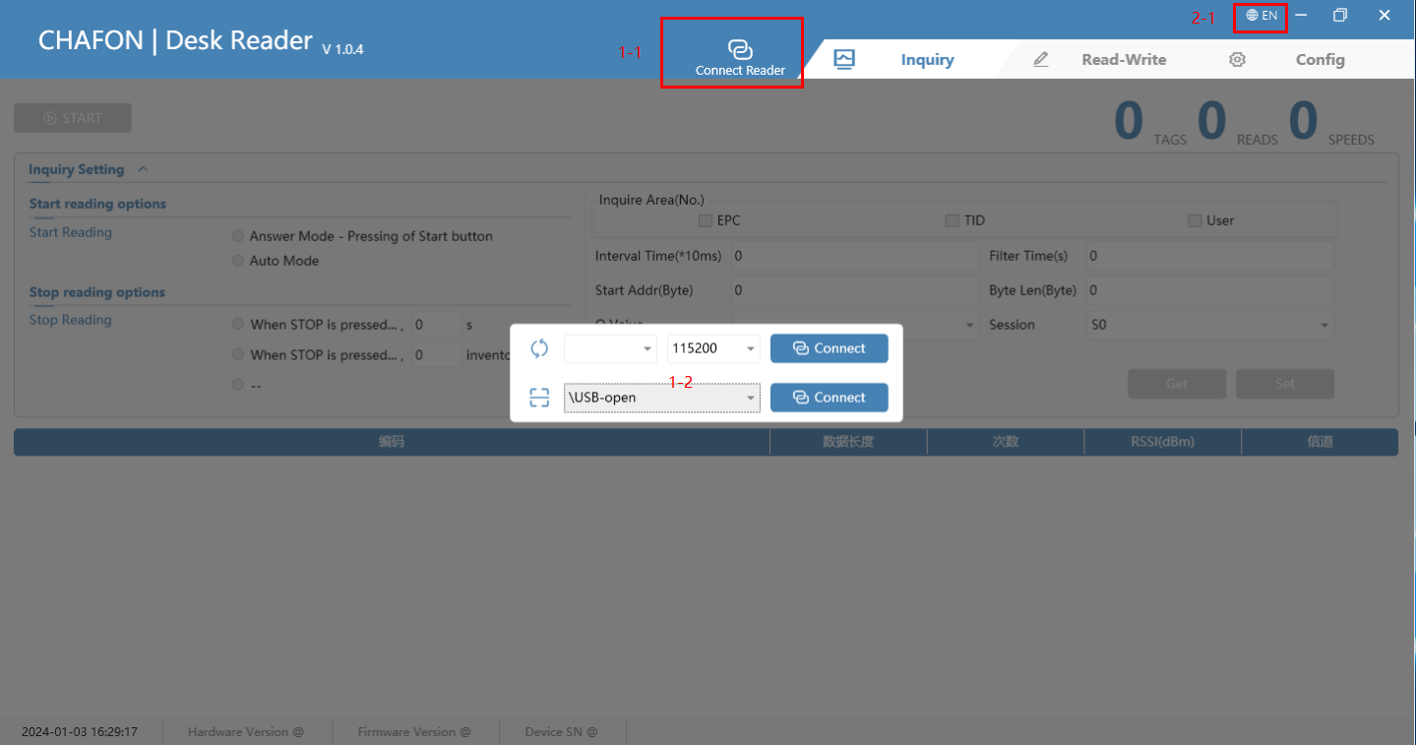

* Double-click Desk Reader.exe to start the software
* Click to “connect reader” (Figure 1-1), the connection form will pop up (Figure 1-2), at this time, we can choose USB connection or RS232 connection
* Click on Figure 2-1 to switch languages. Currently, only Chinese and English are supported.

## 3.Query

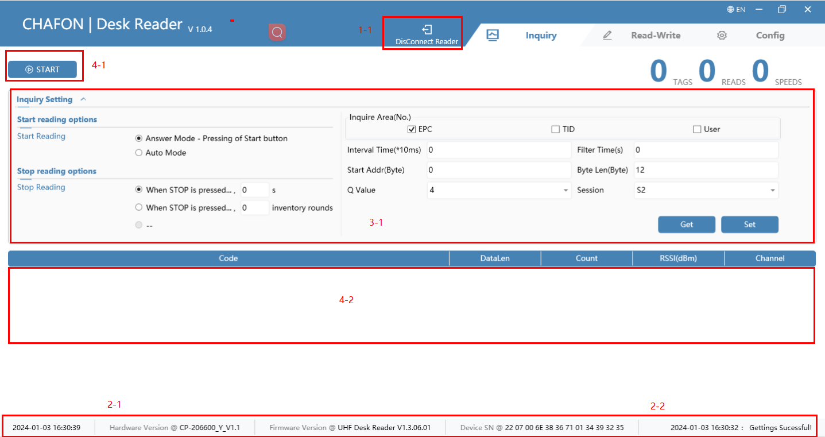

* After the connection is successful, the icon of the connected card reader will change to “disconnected reader” (Figure 1-1)
* The status bar at the bottom of the interface displays the firmware version, hardware version, current time and other information of the connected card reader (Figure 2-1); the lower right corner is the operation log (Figure 2-2)
* We can set reader parameters before querying (Figure 3-1)
* Click the START button (Figure 4-1) to start the query, and the query results will be displayed in Figure 4-2

## 4.Read and write

### 4.1) Read and write tags

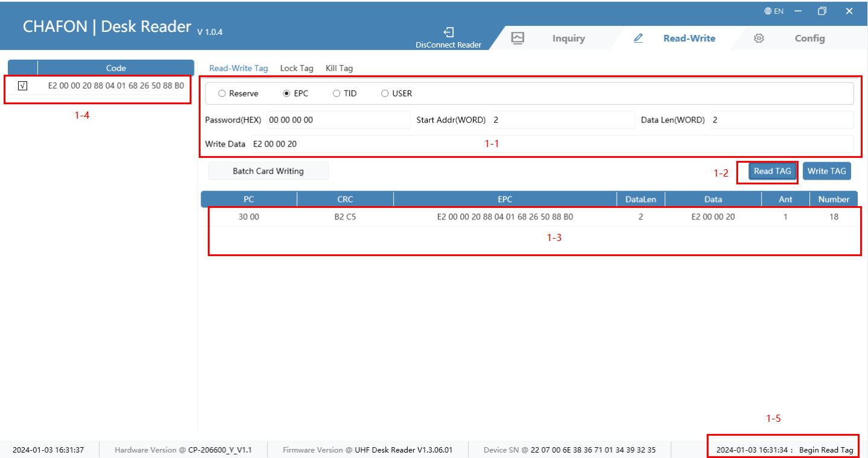

* Before reading and writing tags, we can set the tags in the area in Figure 1-1.
* Click on Figure 1-2 to perform tag reading and writing operations
* Read tag: Select the tag in Figure 1-4 to perform the read operation. If successful, the tag information will be displayed in the area of Figure 1-3; if no specific tag is selected in Figure 1-4, the read operation can also be performed. At this time, the read and write operations are successful except In addition to being displayed in the area of Figure 1-3, it will also determine whether the label exists in Figure 1-4. If it exists, it will be automatically checked, and the data column will be assigned to the data writing text box.
* Write tag: Select the tag in Figure 1-4 to perform the write operation. After successfully writing the tag, the tag information will be displayed in the area of Figure 1-3.
* Reading and writing fail. Figure 1-5 will display the specific error message.

### 4.2) Write tags in batches

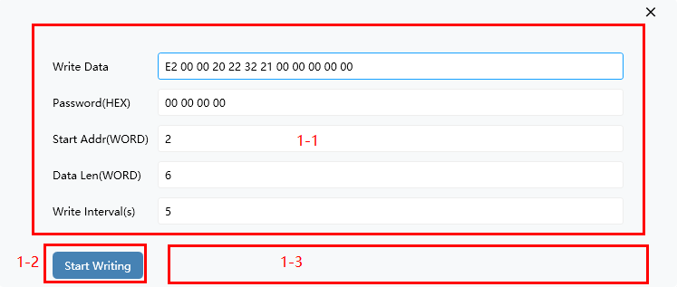

* Clicking the batch card reading button will pop up the small window shown above. We can batch write cards through this form.
* Set the relevant information in Figure 1-1, where the write interval indicates how many seconds to rest before performing a write operation every time a card is successfully written.
* Click Start Writing (Figure 1-2) to start writing cards in batches. At this time, the button text will change to Stop Writing. Click the button again to stop the operation.
* The writing information will be displayed in Figure 1-3. Regardless of success or failure, the attempt will be repeated (the failed attempt interval is fixed at 2s, regardless of the writing interval)

### 4.3) lock tag

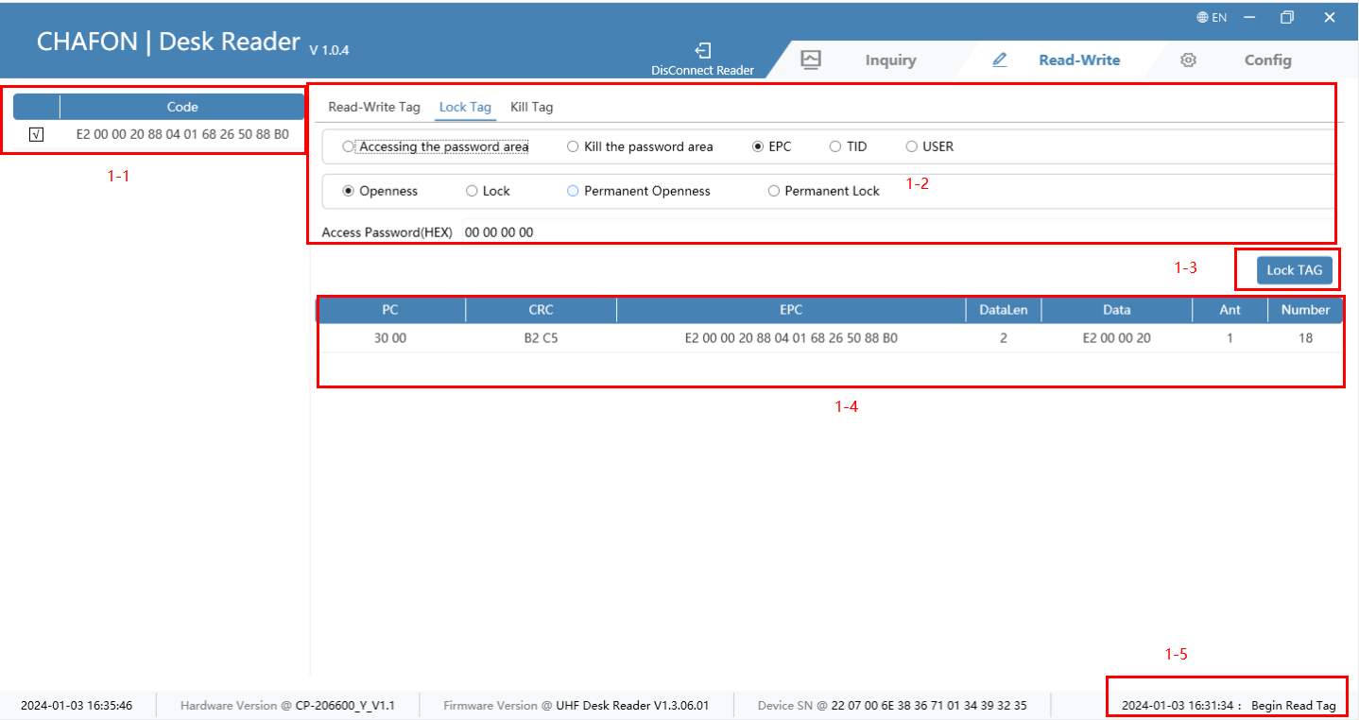

* Select the label we want to operate in the area in Figure 1-1
* Edit the content of the operation label in Figure 1-2
* Click to lock the label (Figure 1-3), and the system will perform corresponding operations on the label based on the content in Figure 1-2. If successful, the information in Figure 1-4 will be displayed. Otherwise, please pay attention to Figure 1-5 below. error message

### 4.4) Kill tag

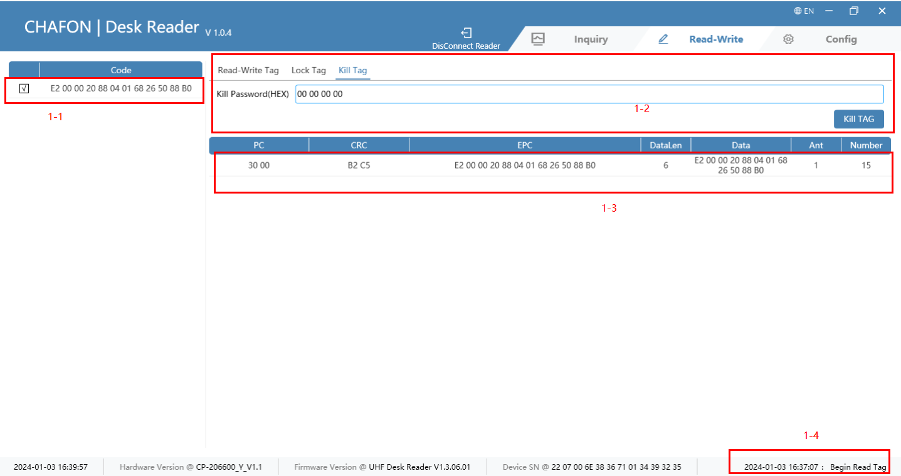

* Select the tag to be inactivated in Figure 1-1
* After entering the kill password, click the kill tab to perform the kill operation (Figure 1-2). If successful, the information will be displayed in the 1-3 area. Otherwise, you can leave the error message 1-4.
  + - Tags cannot be restored after being killed

### 4.5) Automatically calculate and add PC

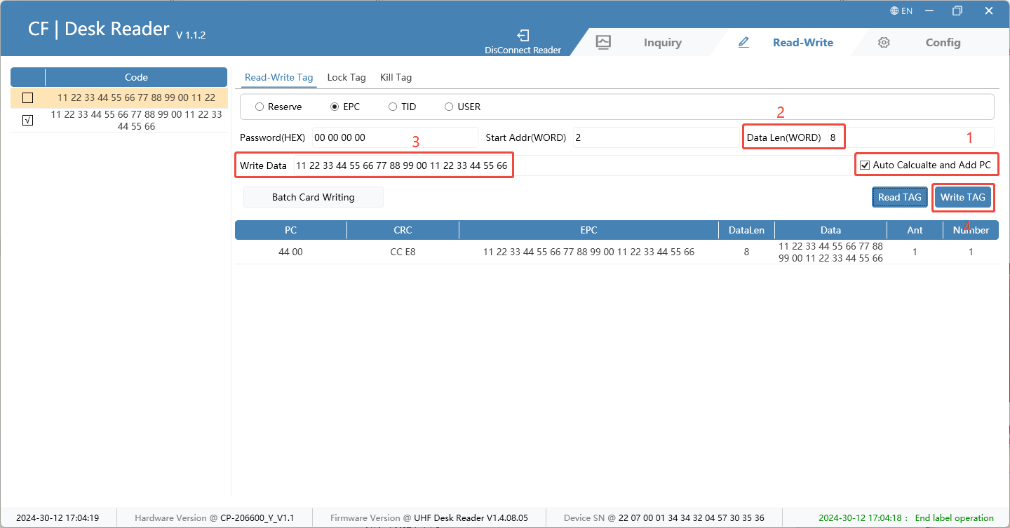

* Automatically calculate and add PC
* If want to modify the data to 16 bytes, one WORD equals two bytes, so you need to configure the data length (WORD) to 8.
* Data writing position, fill in 16 bytes of data, and then write the tag
* After the writing is successful, read it and you will find that the EPC card number becomes 16 Byte data

## 5.Setting

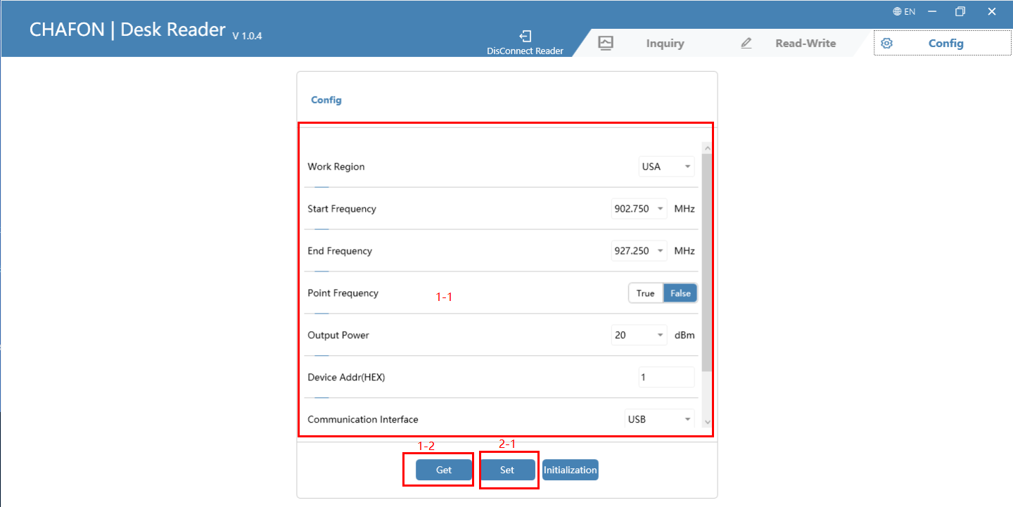

* Through the area in Figure 1-1, we can set the reader’s working frequency band, starting frequency and other information
* Click the Get (Figure 1-2) button to obtain the parameters; click the Set (Figure 2-1) button to set the parameters
* Click Initialize (Figure 2-1) to send initialization instructions to the reader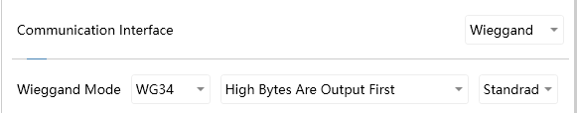
* Set Wiegand,

where direct conversion means the output format is decimal;

The standard representation output format is WG26--2H+4H, WG34--4H+4H;

HEX means the output format is HEX.